MyDoc Communication module
Phase 1

CometChat installation and integration.

Step 1: Download and install cometchat codeigniter plugin in the local copy of the application.

Step 2: Integrate single signon with cometchat.

Step 3: Modify friend list function so that patients or doctors inside a group can see only the admin of their own group at the frontend portal www.mydoc.com

Step 4: Allow only incoming chat for the administrators.

Step5: Handle click event on the username, if the user is a doctor/patient, display the profile page of patient/doctor.

Step 6: Let the admin create/save notes about the chat. I am thinking about providing a button inside the cometchat chat panel. The button will popup a textarea and user will be able to enter the notes right from inside the cometchat window. We don’t know exactly how we will be implementing this step so we don’t have a good estimate.
Estimated Time: 8 hours.
Actual time spent:

Step 7: Create a page in admin section where he can see a list of all chats.
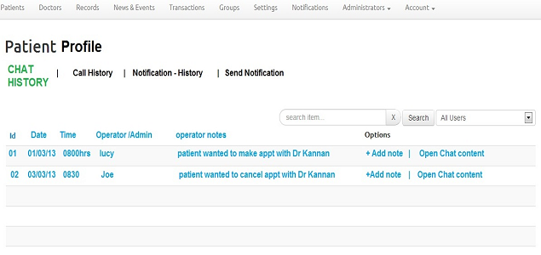

Step 8: In the chat sessions list add ability to add more notes. Only the more recent node will be visible, to see other notes user will click on most recent note and it will show all notes in a pop up. Clicking on Add note will popup a textarea with a save button, user will be able to add plain text and press save to save the entered text in a db table. Should be done using Ajax (no new page is needed and page will not get refreshed)..
Estimated Time: 8 hours.
Actual time spent:

Step 9: In the chat sessions list, allow user to view the chat contents. Chat content will be displayed in a scrollable popup.
Estimated time: 4 hours.
Actual time spent:

Step 10: Let the super admin view everyone’s chat session and view the notes.

Twilio integration

Step 1: Download and install twilio for codeigniter. http://blog.openvbx.org/2011/08/usingthenewtwilioserviceslibraryinacodeigniterapplication/ Estimated Time: 1 hour

I have created a twilio class for sending SMS and calling also.

Step 2: In the MessageSender class we created for previous milestones implement function SendSMS. You should be able to pass sender number, receiver number and text message to this function and this function will send message. – Not required as I have created it

Step 3: Complete implementation of sms in event/news module and notifications module. – already done

Step 4: Create table to save all notifications to manage notifications history.

Step 4.1: To add send notification as a shortcut from profile page to send message by email/sms/app notification to that particular patient or doctor profile.

Step 5: Create page to see the communication history with a patient. Provide a link on the patient’s profile page, upon clicking on the link, you will see the communications history page. This page is going to have three tabs Chat history, Call history and Notification history. Notification and call history tabs will have links “Send notification” and “Call Now”

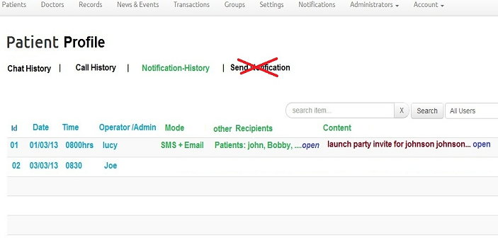

Step 6: Add call now button on the patients list page. We need to know more about this link. Its a call button from twilio, which can be used, to open a live call window, with a note section to
add by admin during call.; So its a outgoing call only option via twilio.
In this phase we will only provide the button and ability to make call. If anything else is needed, it will be managed in later phases of the applicaiton.

------------------

User ID for Patient is bcs.shashi@gmail.com and password is winter123.
User ID for doctor is doc@my.doc and password is mydoc123.
User Id for github is rahul-doc Password is winter123.
This module is limited to setting up chat between the back end admins to front end patients and doctors for 1 on 1 chat. Archiving these. Then having call out using twilio from profile pages on backend, and archiving those calls with call note by admin.
having call out using twilio from profile pages on backend, and archiving those calls with call note by admin.
